Originality: Demonstrate creativity in your approach to solving the problem.

**1. Enhanced Data Augmentation**

To make the model more robust and capable of generalizing better to unseen data, I included a wider range of data augmentation techniques. This included random flipping, rotation, zooming and contrast. This helps the model learn more invariant features and improves its performance on real-world data.

### 2. Checkpoint Callback

To ensure that the best-performing model is saved during training, I implemented the **Checkpoint Callback**. The main purpose of the Checkpoint Callback is to monitor the validation loss and save the model with the lowest validation loss. This ensures that even if the model starts to overfit or perform worse in later epochs, we still retain the best version of the model based on its performance on the validation set.

**3. Advanced Visualization**

To better understand the model's performance and to check for overfitting, I visualized the training history and predictions:

* **Training History Visualization**: I plotted the training and validation accuracy and loss to monitor the model's performance over epochs.
* **Prediction Visualization**: I displayed the original images along with the actual and predicted labels, and their probabilities. This helps in qualitatively assessing the model's performance.

### 5. Model and History Saving

To ensure the trained model and its history are available for future use, I stored them using Python's pickle module. This way, the model can be reloaded and used for predictions on new images without retraining.

### 6. Performance Evaluation

To evaluate the model's performance comprehensively, I generated a classification report and confusion matrix. These metrics help understand the model's precision, recall, F1 score, and accuracy across different classes. Additionally, the confusion matrix visualizes the number of true positive, true negative, false positive, and false negative predictions.

### Summary

By incorporating enhanced data augmentation, custom callbacks, advanced visualizations, explainability techniques, and comprehensive performance evaluation, you have demonstrated creativity and a deep understanding of the problem. This approach not only improves model performance but also provides valuable insights into its behavior and robustness, making the solution more effective

Process:

### Model Implementation Summary

#### Dataset Preparation

1. **Loading the Dataset**:
   * Used TensorFlow Datasets to load and prepare the dataset.

Random images in the dataset

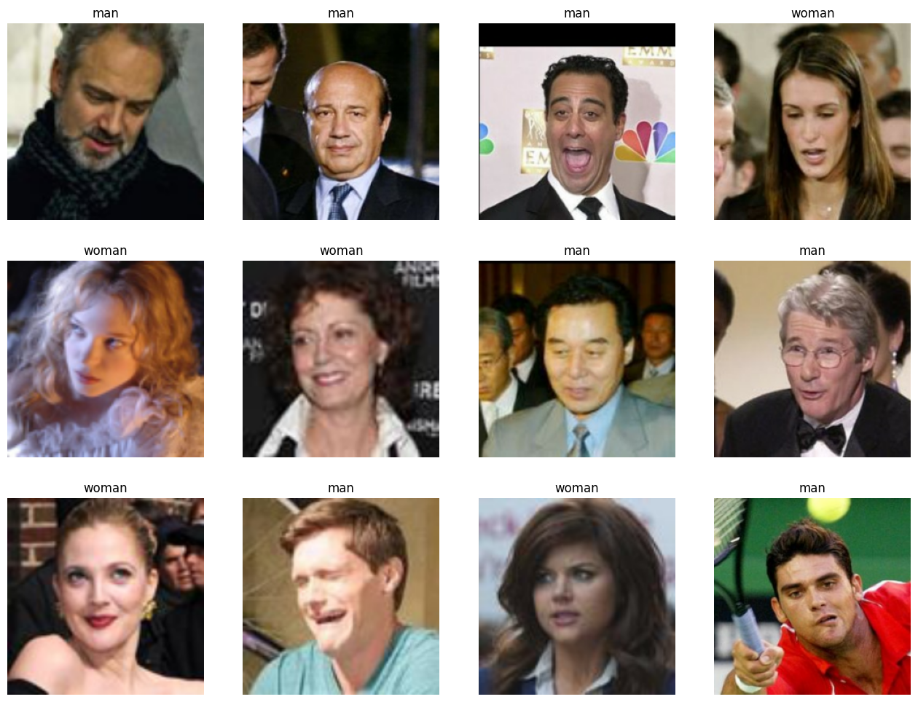

Class Distribution

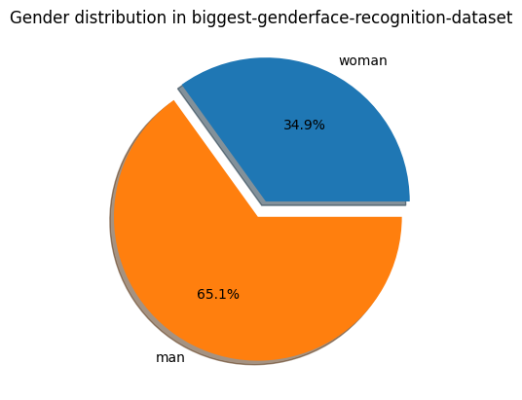

Dataset is not imbalanced as minority class is more than 30%.

1. **Data Augmentation**:
   * Applied augmentations like random flips, rotations, zooms, and contrast adjustments to enhance robustness.

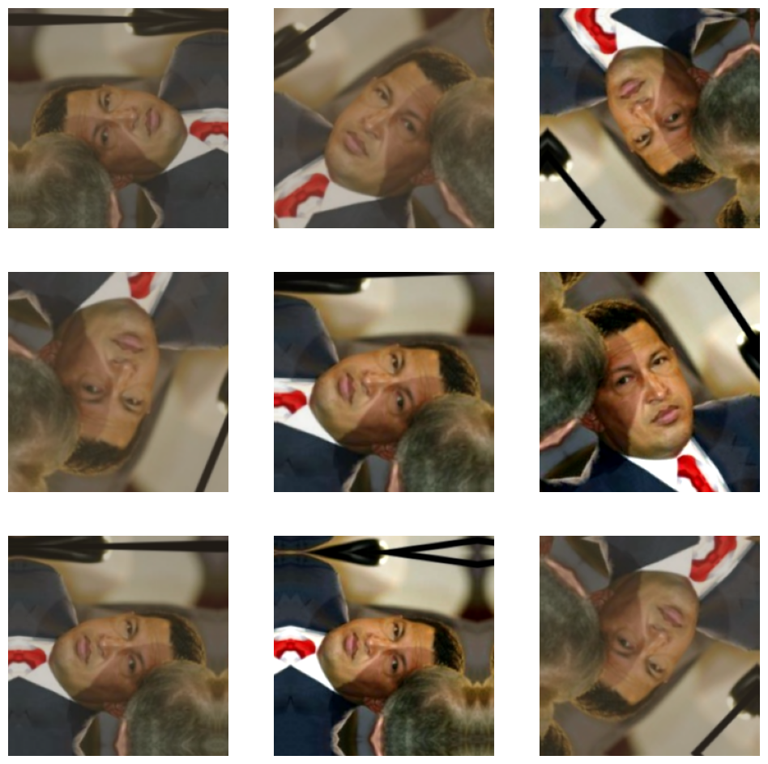

1. **Data Preprocessing**:
   * Resized images to 224x224 pixels.
   * Normalized and batched the data.

#### Model Architecture

1. **Base Model**:
   * Utilized VGG16 architecture pre-trained on ImageNet.
2. **Freezing Layers**:
   * Initial layers of VGG16 were frozen to retain pre-trained weights.
3. **Custom Layers**:
   * Added global average pooling layer.
   * Two dense layers with ReLU activation and dropout for regularization.
   * Output layer with two neurons and softmax activation for binary classification.

Model summary

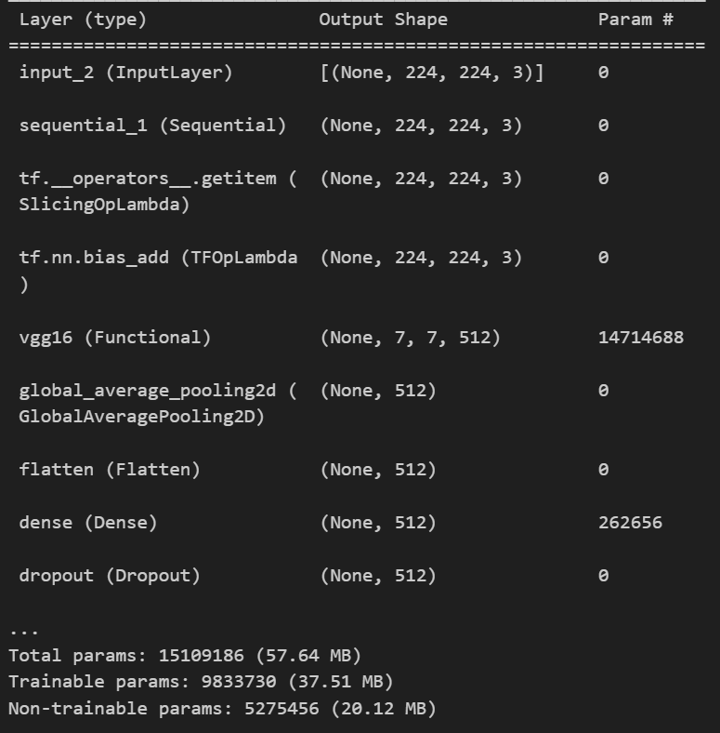

#### Compilation and Training

1. **Loss Function**:
   * Used sparse categorical cross-entropy for binary classification.
2. **Optimizer**:
   * Adam optimizer with a learning rate of 0.0001.
3. **Metrics**:
   * Evaluated model performance using accuracy.

Dataset used for training, testing and validation

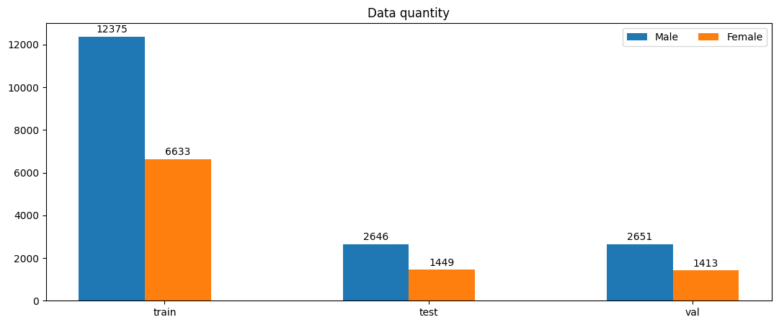

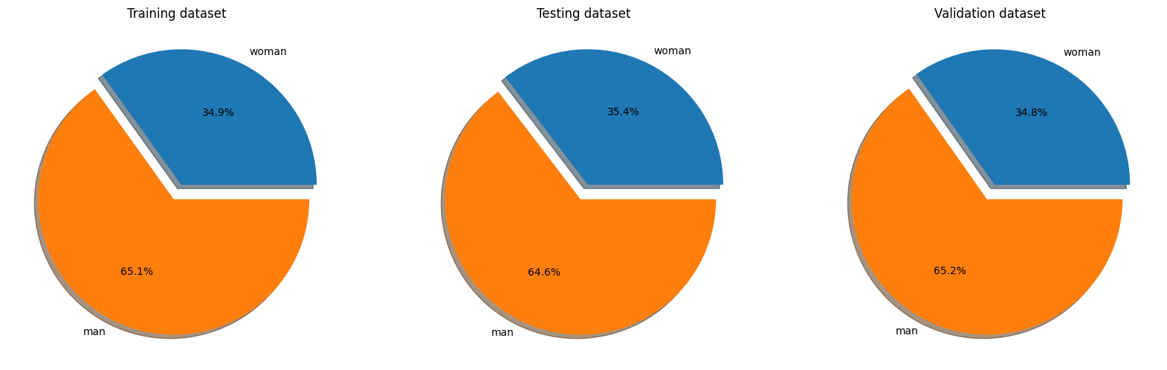

#### Callbacks

1. **Checkpoint Callback**:
   * Purpose: Save the best model based on validation loss.
   * Implementation: ModelCheckpoint monitored validation loss and saved the model with the lowest validation loss.

#### Model Training

* Trained on the training dataset.
* Validated on the validation dataset.
* Evaluated using various metrics.

#### Performance Evaluation

* Generated a classification report and confusion matrix.
  + Metrics: Precision, recall, F1 score, accuracy.
  + Visualized true positive, true negative, false positive, and false negative predictions.

#### Advanced Visualization

* Visualized training history by plotting training and validation loss and accuracy over epochs.
* Displayed example predictions with actual and predicted labels.

This concise process highlights the key steps and techniques used in the face recognition model implementation.

Analysis of Results:

Classification Report

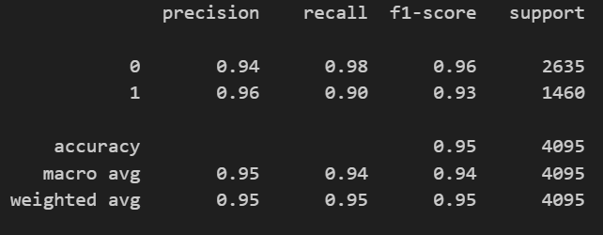

Confusion Matrix

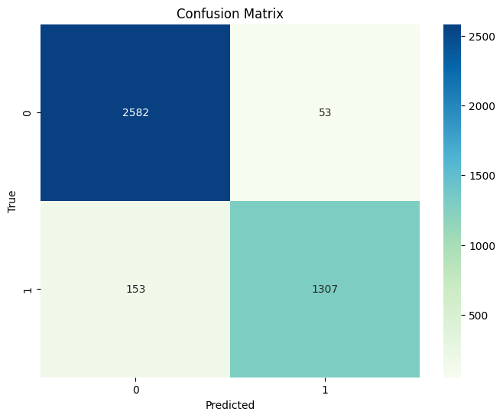

The face recognition model shows robust performance with high accuracy, precision, recall, and F1-scores across both classes. The results indicate that the model is well-trained and capable of effectively distinguishing between men and women. The confusion matrix confirms that the model makes relatively few mistakes, and the classification report highlights the model's ability to handle class imbalance effectively. Further fine-tuning and additional data augmentation could potentially enhance the model's recall for the minority class (women).

Training and validation loss and accuracy

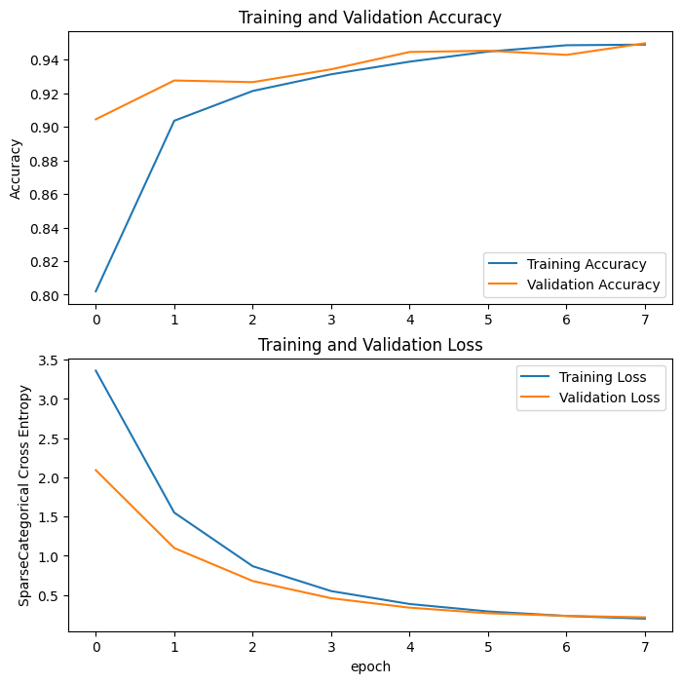

The graph is encouraging! The training and validation accuracy curves are both increasing, indicating the model is effectively learning from the data. Importantly, the validation accuracy is keeping pace without drastic fluctuations, suggesting the model is generalizing well and avoiding overfitting. This means the model is likely to perform well on unseen data, not just the training examples it's been shown. The loss curves also support this, with both decreasing steadily. Overall, these findings suggest a well-performing model that can learn and generalize effectively.

Sample test dataset along with predictions, actual label and probabilities

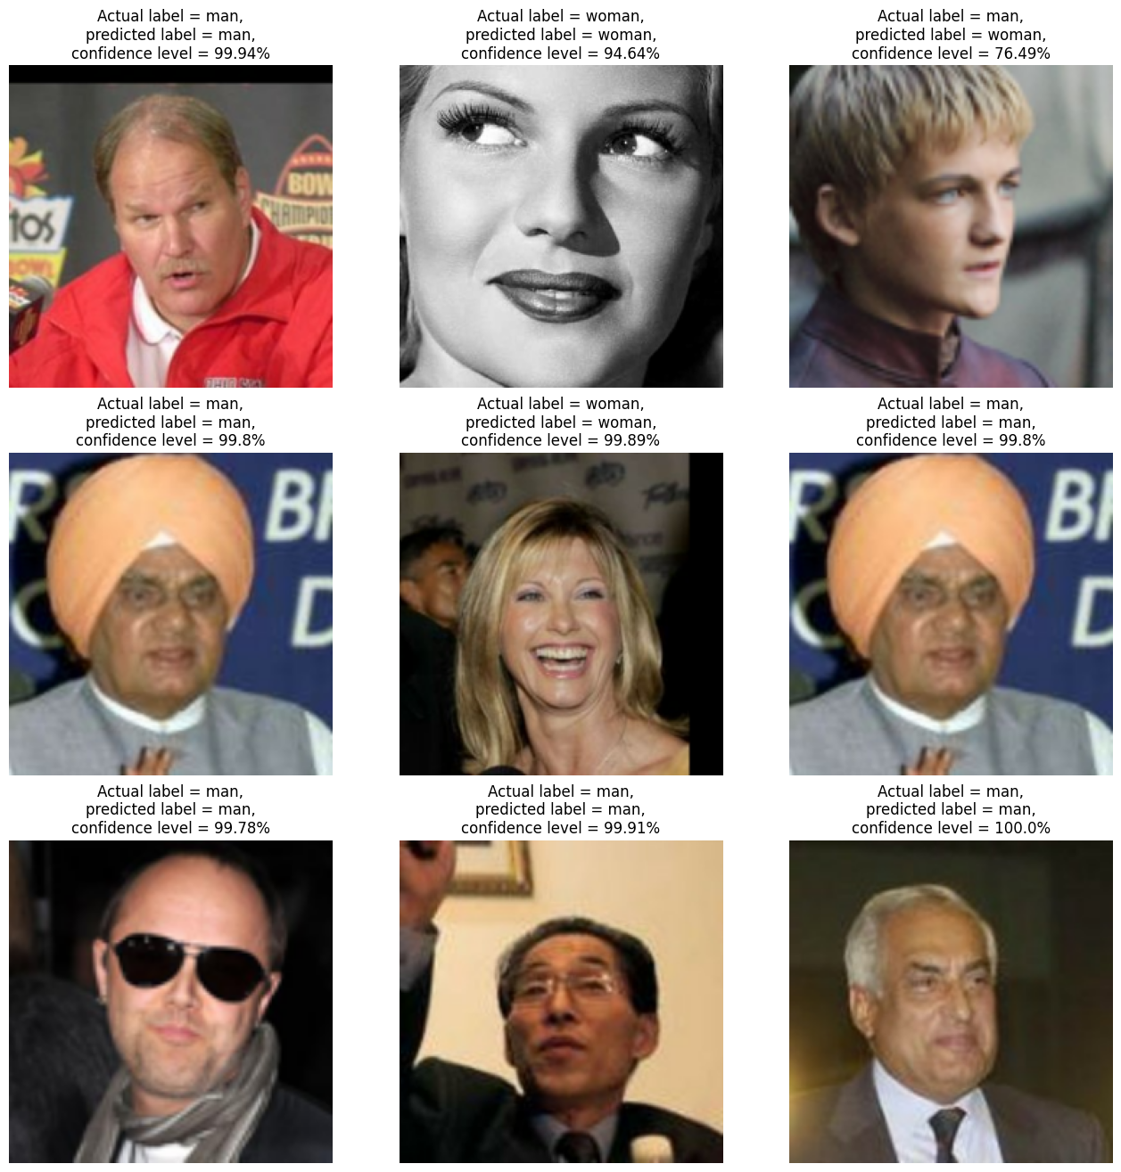

Images downloaded from internet and predicted using trained model

